**Assignment: Populate Data**

Brandon Trinkle

Arizona State University

IFT 300

Professor Ashish Gulati

11/12/2024

**Assignment: Populate Data**

1. Write SELECT INTO statements to create two test tables named VendorCopy and InvoiceCopy that are complete copies of the data in the Vendors and Invoices tables.

/*

** Author: Brandon Trinkle

** Course: IFT/300

** SQL Server Version: Microsoft SQL Server 2012 (SP1)

** OS : Windows

** History

** Date Created Comments

** 11/26/2024

*/

SELECT * INTO VendorCopy

FROM Vendors;

SELECT * INTO InvoiceCopy

FROM Invoices;

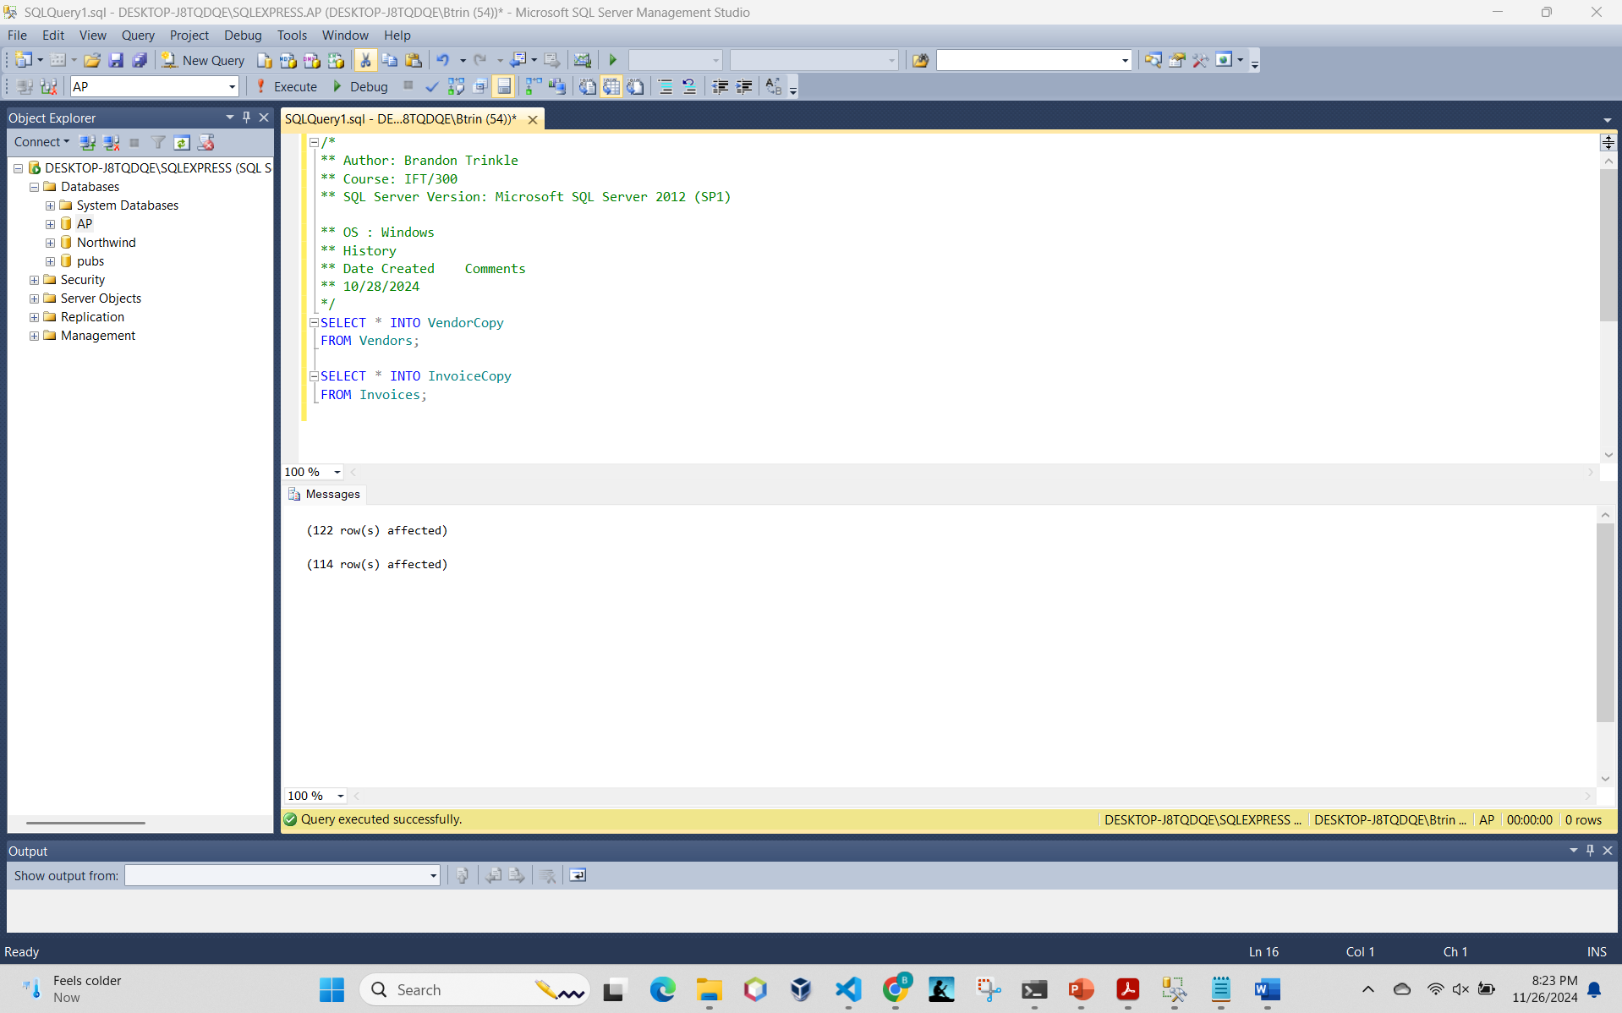

1. Write an INSERT statement that adds a row to the InvoiceCopy table with the following values:

/*

** Author: Brandon Trinkle

** Course: IFT/300

** SQL Server Version: Microsoft SQL Server 2012 (SP1)

** OS : Windows

** History

** Date Created Comments

** 11/26/2024

*/

INSERT INTO InvoiceCopy (VendorID, InvoiceTotal, TermsID, InvoiceNumber, PaymentTotal, InvoiceDueDate, InvoiceDate, CreditTotal, PaymentDate)

VALUES (32, 434.58, 2, 'AX-014-027', 0.00, '2023-05-08', '2023-04-21', 0.00, NULL);

1. Write an UPDATE statement that modifies the VendorCopy table. For each vendor that has an account number of 400, change the account number to 403.

/*

** Author: Brandon Trinkle

** Course: IFT/300

** SQL Server Version: Microsoft SQL Server 2012 (SP1)

** OS : Windows

** History

** Date Created Comments

** 11/26/2024

*/

UPDATE VendorCopy

SET DefaultAccountNo = 403

WHERE DefaultAccountNo = 400;

